Linear Regression
Linear regression is very good to answer the following questions:
- Is there a relationship between 2 variables?
- How strong is the relationship?
- Which variable contributes the most?
- How accurately can we estimate the effect of each variable?
- How accurately can we predict the target?
- Is the relationship linear? (duh)
- Is there an interaction effect?

Estimating the coefficients
- one variable and one target. Then, linear regression is expressed as:
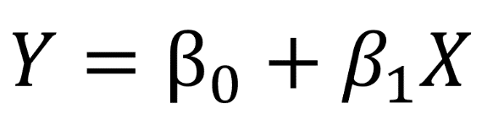
To find the parameters, we need to minimize the least squares or the sum of squared errors.

The error is easily calculated with:

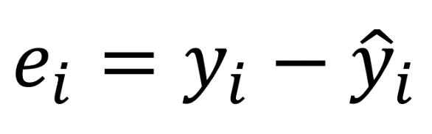
We square the error, because the prediction can be either above or below the true value, resulting in a negative or positive difference respectively.

If we did not square the errors, the sum of errors could decrease because of negative differences and not because the model is a good fit.

Also, squaring the errors penalizes large differences, and so the minimizing the squared errors “guarantees” a better model.

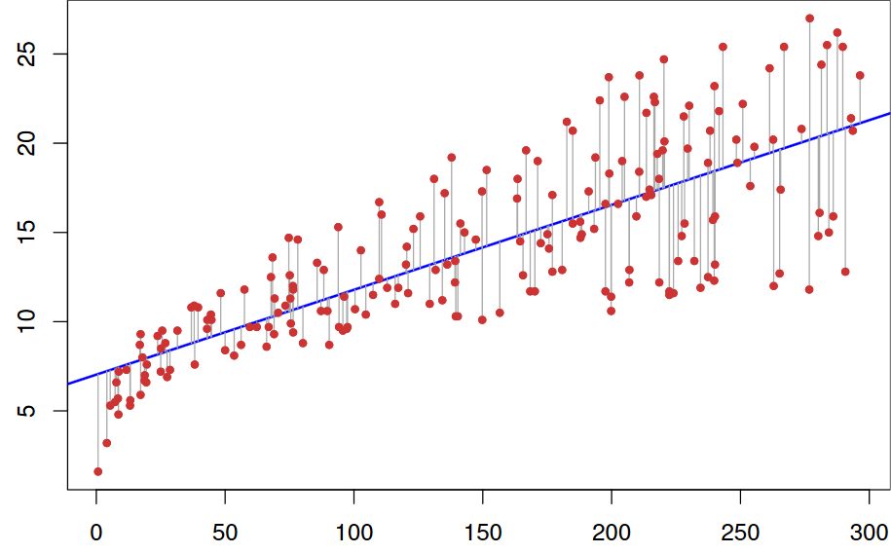
In the graph above, the red dots are the true data and the blue line is linear model. The grey lines illustrate the errors between the predicted and the true values. The blue line is thus the one that minimizes the sum of the squared length of the grey lines.

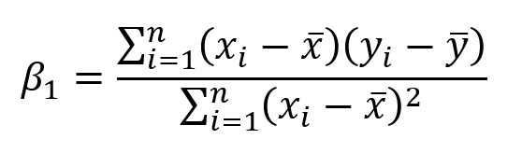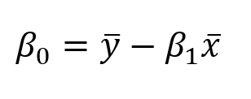
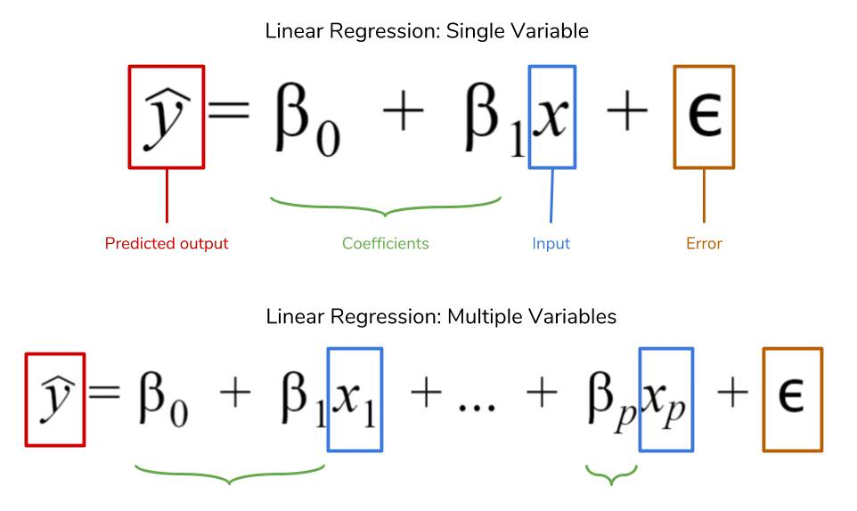
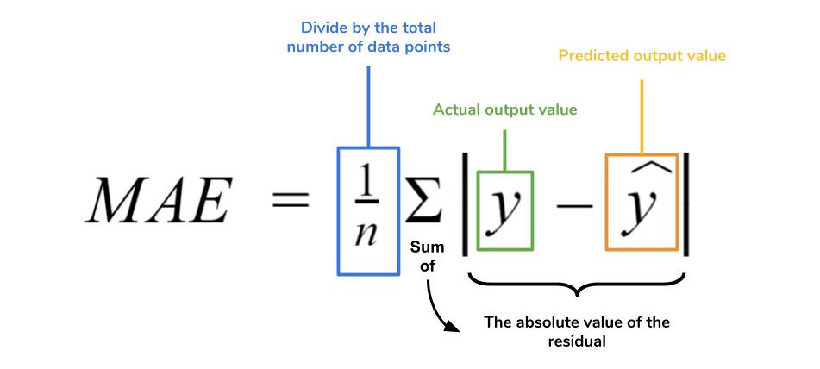
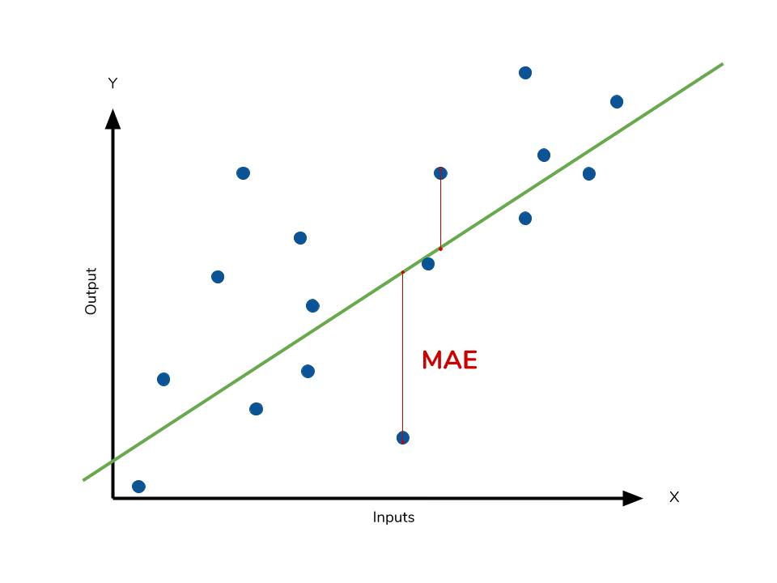
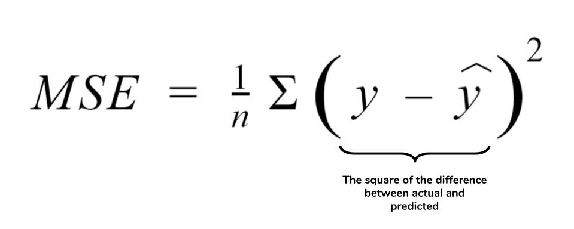
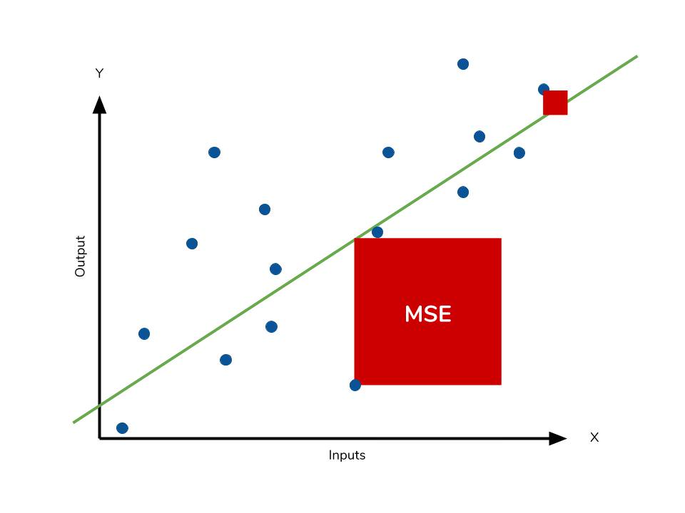
Root Mean Squared Error (RMSE)
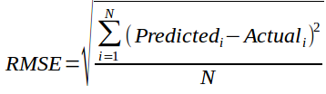

R Squared (R²)

The coefficient of determination, or R², is another metric we may use to evaluate a model and it is closely related to MSE, but has the advantage of being scale-free — it doesn’t matter if the output values are very large or very small, the R² is always going to be between -∞ and 1.

When R² is negative it means that the model is worse than predicting the mean.

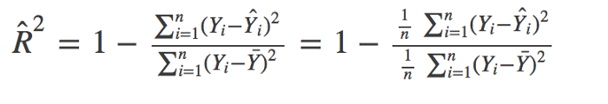

The numerator is MSE (average of the squares of the residuals) and the denominator is the variance in Y values. Higher the MSE, smaller the R_squared and poorer is the model.

We can calculate the adjusted R2 from R2 with a simple formula given here.

Adj r2 = 1-(1-R2)*(n-1)/(n-p-1)

Where n is the sample size and p is the number of independent variables.

Multiple Linear Regression
The equation is very similar to simple linear regression; simply add the number of predictors and their corresponding coefficients:
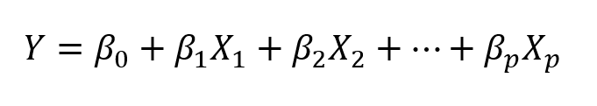
Multiple linear regression equation. p is the number of predictors

Table :- the x_{i} column shows scores on the aptitude test. Similarly, the y_{i} column shows statistics grades.

Student | x_{i} | y_{i} | (x_{i}-x) | (y_{i}-y)
1 | 95 | 85 | 17 | 8
2 | 85 | 95 | 7 | 18
3 | 80 | 70 | 2 | -7
4 | 70 | 65 | -8 | -12
5 | 60 | 70 | -18 | -7
Sum | 390 | 385
Mean | 78 | 77

Student | x_{i} | y_{i} | (x_{i}-x)² | (y_{i}-y)²
1 | 95 | 85 | 289 | 64
2 | 85 | 95 | 49 | 324
3 | 80 | 70 | 4 | 49
4 | 70 | 65 | 64 | 144
5 | 60 | 70 | 324 | 49
Sum | 390 | 385 | 730 | 630
Mean | 78 | 77

Student | x_{i} | y_{i} | (x_{i}-x)(y_{i}-y)
1 | 95 | 85 | 136
2 | 85 | 95 | 126
3 | 80 | 70 | -14
4 | 70 | 65 | 96
5 | 60 | 70 | 126
Sum | 390 | 385 | 470
Mean | 78 | 77

The regression equation is a linear equation of the form: ŷ = b₀ + b₁x
regression coefficient (b₁):
b₁ = Σ [ (x_{i} - x)(y_{i} - y) ] / Σ [ (x_{i} - x)²]
b₁ = 470/730
b₁ = 0.644
b₀ = y - b₁ * x
b₀ = 77 - (0.644) (78)
b₀ = 26.768
Therefore, the regression equation is: ŷ = 26.768 + 0.644x.
If a student made an 80 on the aptitude test, the estimated statistics grade (ŷ) would be:
ŷ = b₀ + b₁x
ŷ = 26.768 + 0.644x = 26.768 + 0.644 * 80
ŷ = 26.768 + 51.52 = 78.288

